Tirumala Reddy Konireddy

sTUDENT ID  16174347

LAB 04 REPORT

1. I had done a recommendation application which recommends the users about particular items which are more likely to buy by users by analyzing the items bought by all users.
2. For this first I had taken a data file in csv format with users and the list of items bought by users.

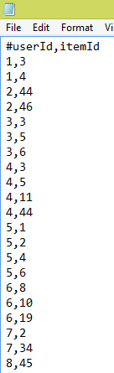

1. I had used a recommender program in xml(pom.xml) to analyze this data and to output recommenders for every user.



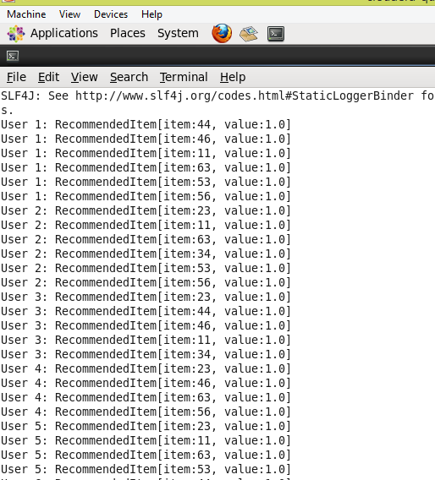

1. I stored the output of recommender program into a text file using

Command : mvn exec:java -Dexec.mainClass="com.unresyst.UnresystBoolRecommend" >output.txt



1. I had entered manually the output recommended items for every user to solr server under lab_04 collection : <http://localhost:8983/solr/#/lab_o4>

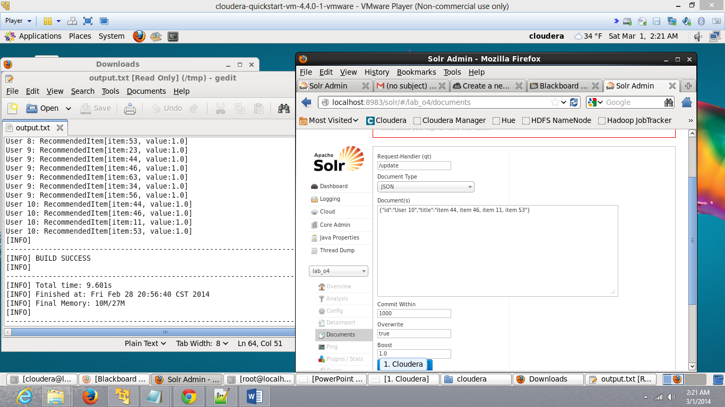

1. I had verified the entered data in solr server location : http://localhost:8983/solr/lab_o4/select?q=*%3A*&wt=json&indent=true through query *.*, query User 1.* etc.,

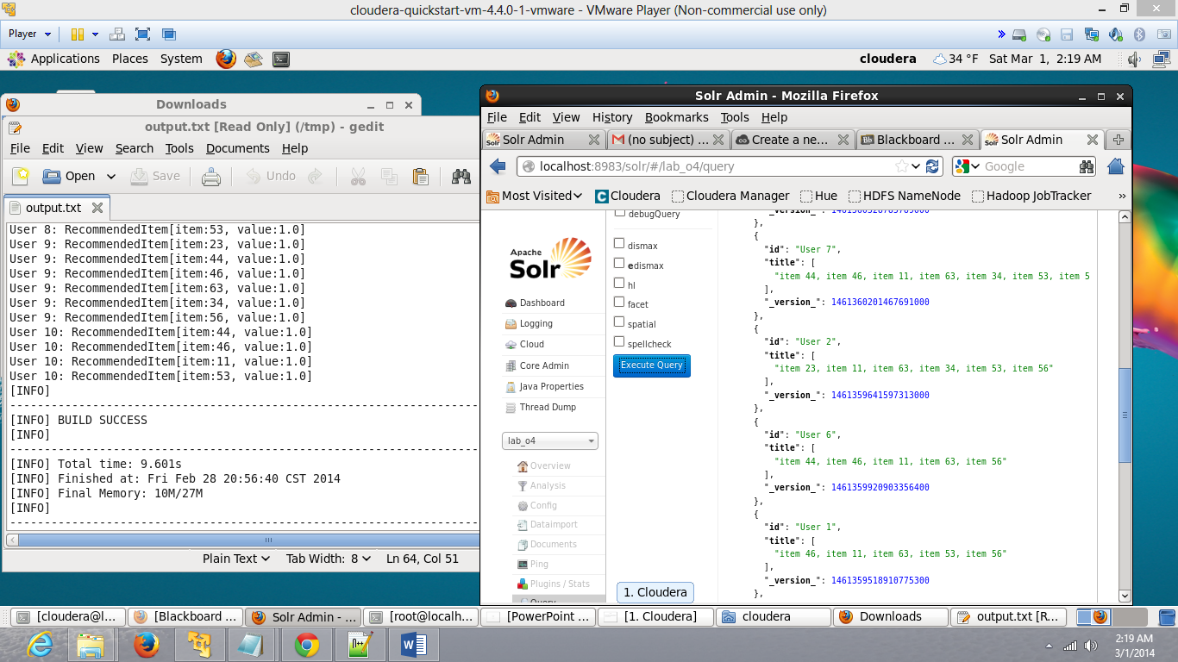

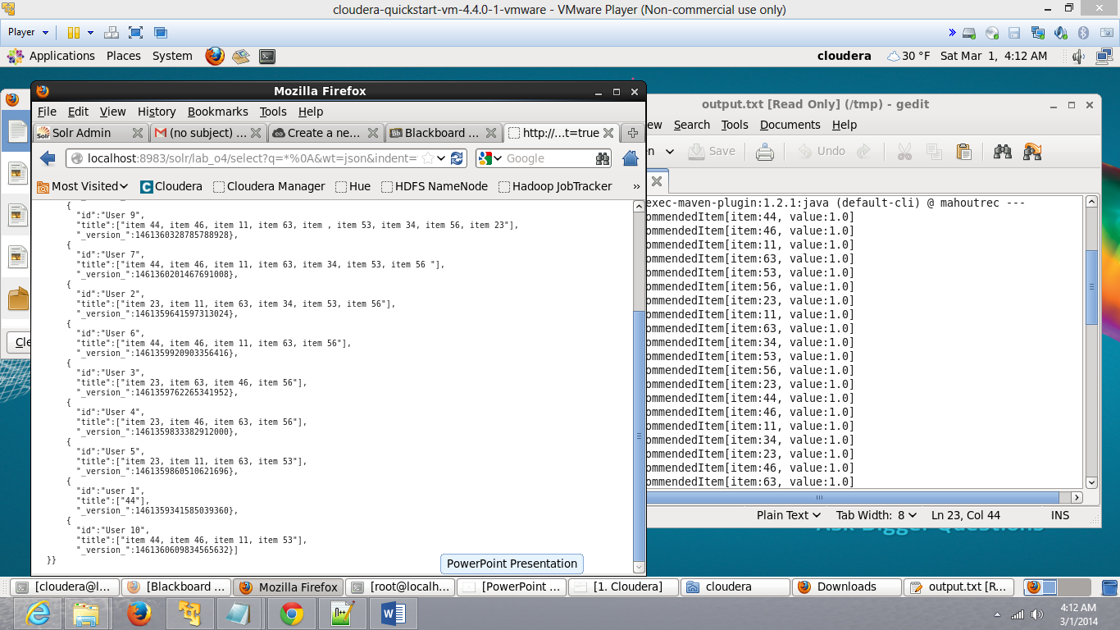

1. I had tried to retrieve recommended items for every user from solr server using mobile application written in jquery.

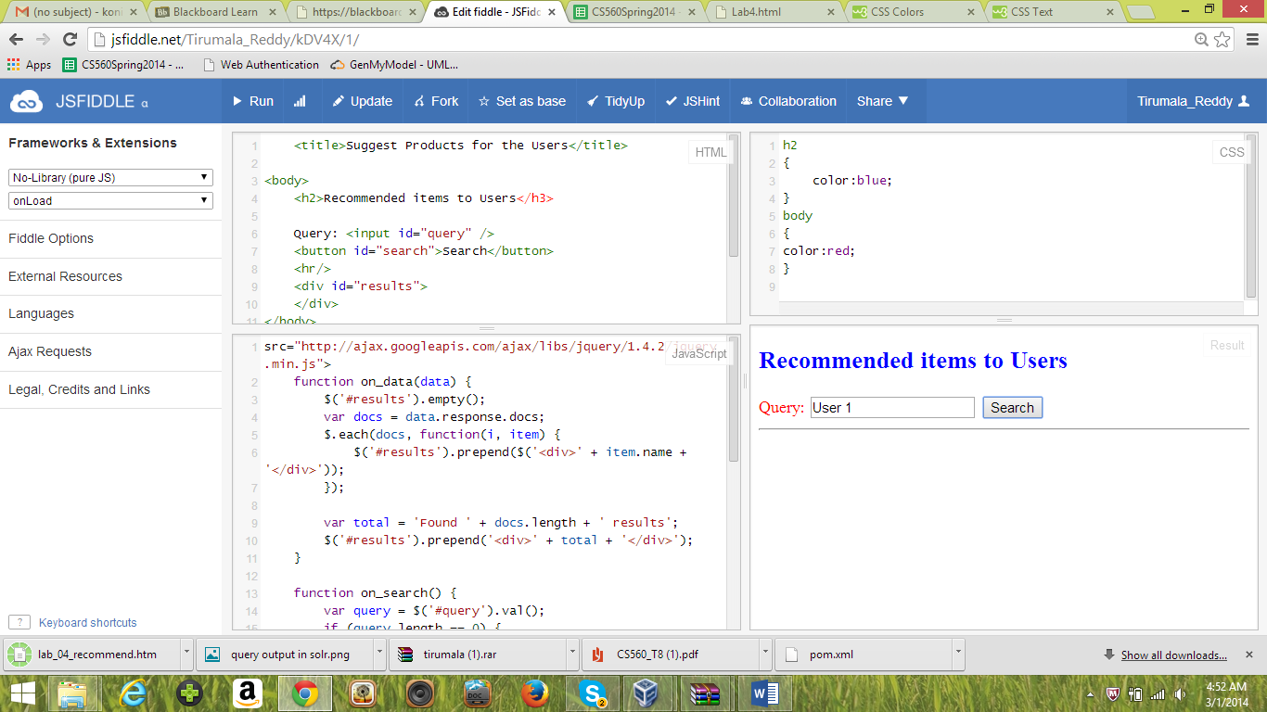

The End